EXP 29

AIM: Design DFA using simulator to accept the input string “bc” ,”c”,and ”bcaaa”.

INPUT:

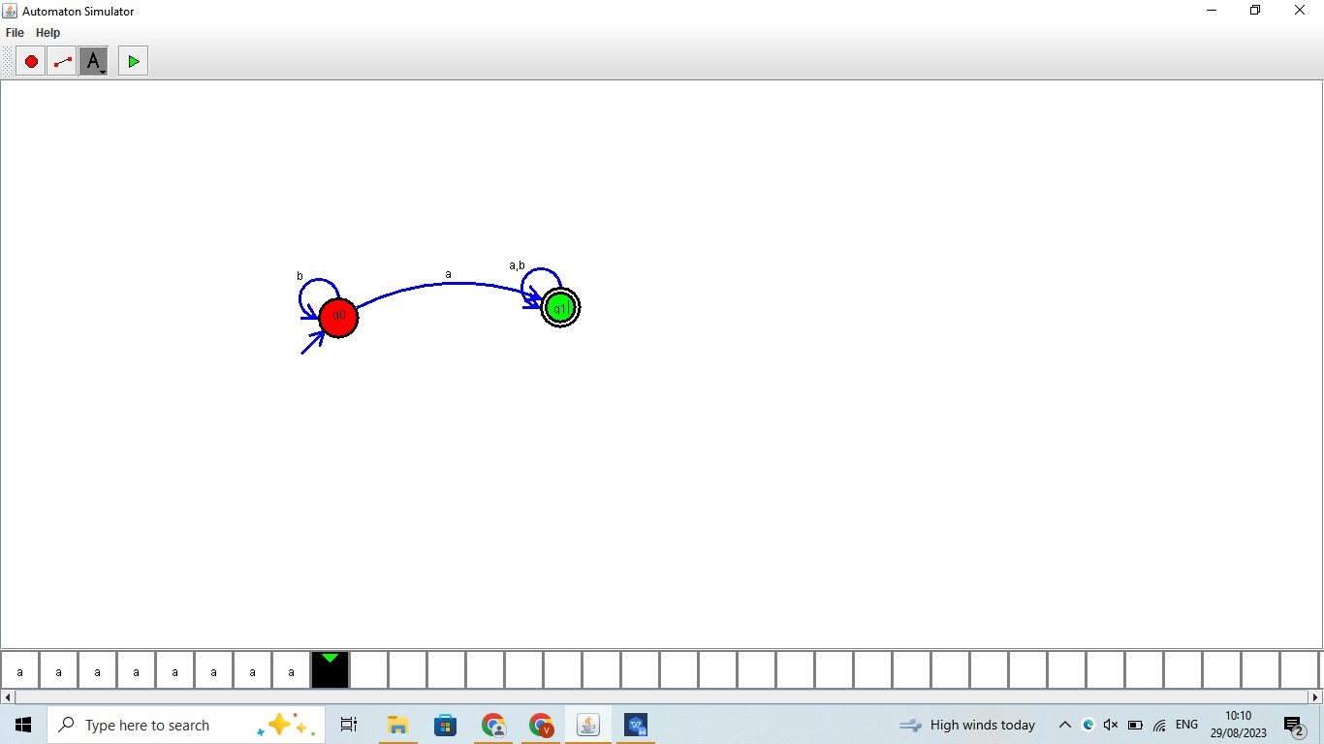

OUTPUT:



RESULT: the DFA using simulator to accept the input string “bc” ,”c”,and ”bcaaa” is successfully verified.